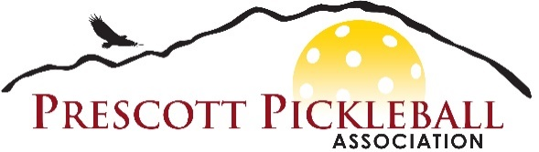

**PRESCOTT PICKLEBALL ASSOCIATION**

**RELEASE, PERMISSION AND INDEMNITY AGREEMENT**

EVENT DIRECTOR(S) AND OTHERS

City of Prescott, Prescott Pickleball Association (PPA) members, and their agents

All PPA activities including lessons, play-groups, social play, tournaments and other events organized and operated by the PPA organization.

Release. In consideration of being permitted to participate in any way in any of the Events named above, I, for myself, my child, my ward, my heirs or assigns, hereby release, waive, discharge and covenant not to sue the Prescott Pickleball Association (PPA) as well as The City of Prescott, the Event Director(s) and Others named above, their officers, employees, volunteers, and agents from liability from any and all claims resulting in personal injuries, accidents or illnesses (including death) and property loss arising from, but not limited to, participation in the Event.

Assumption of Risk. Participation in the Event carries with it certain inherent risks that cannot be eliminated regardless of the care taken to avoid injuries. The specific risks vary but include 1) minor injuries such as bruises, sprains and dehydration, 2) major injuries such as eye injuries, joint or back injuries, heat stroke, heart attacks, and concussions, and 3) catastrophic injuries such as paralysis and death. I have read the previous paragraphs and I know, understand and appreciate these and other risks that are inherent in playing pickleball. I assert that my participation, and/or the participation of my child or ward, is voluntary and that I knowingly assume all such risks.

Indemnification and Hold Harmless. I also agree to indemnify and hold the PPA, and all named above harmless from any and all claims, actions, suits, costs, expenses, damages and liabilities, including attorneys’ fees, awarded or brought as a result of my involvement, and/or the involvement of my child or ward, in the Event. Use Permission. I give the PPA and its agents and designees, and the City of Prescott, permission to use or distribute, without limitation or obligation, my image, name, voice, and words for any purpose connected with the Event, including promotional, marketing, training, informational, and archival uses.

___________________________ ___________________________ ________

Signature of Participant Print Name of Participant Date ___________________________ ___________________________ ________

Signature of Parent/Guardian, Print Name of Minor’s Parent/Guardian Date